Roblox HRMS Database Tables and Schema
____________________________________________________________________________________________
All tables that belong to roblox_hrms database with all their schema depicted clearly for future reproduction.
- roblox_ hrms database
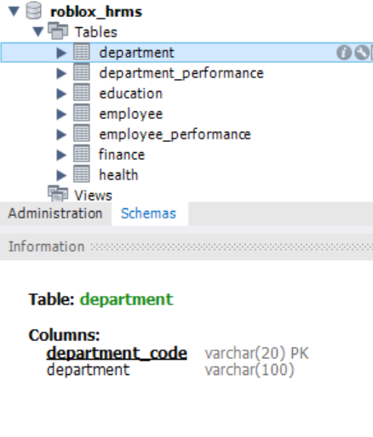
- department_performance table and schema
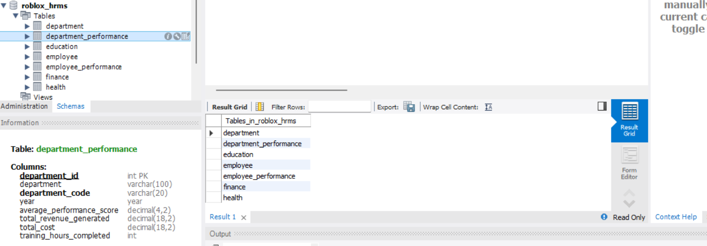

- education table and schema
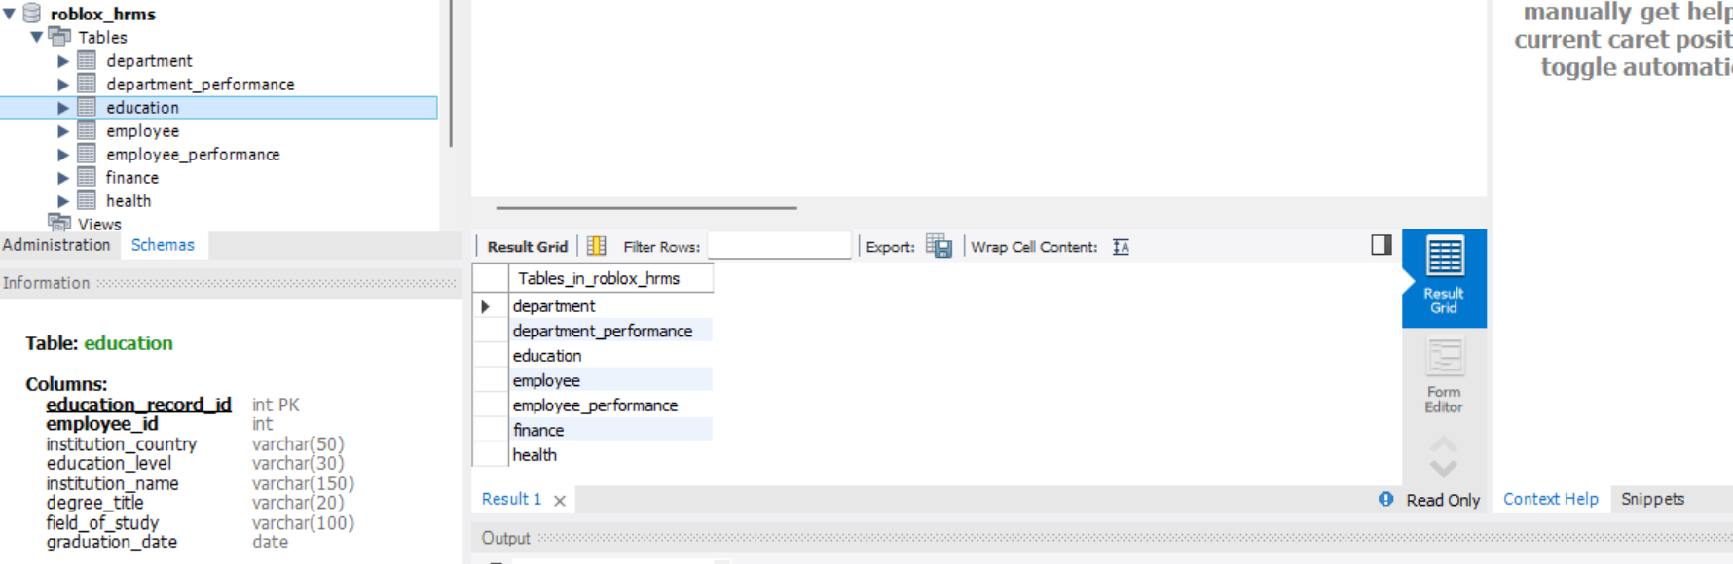

- employee table and schema
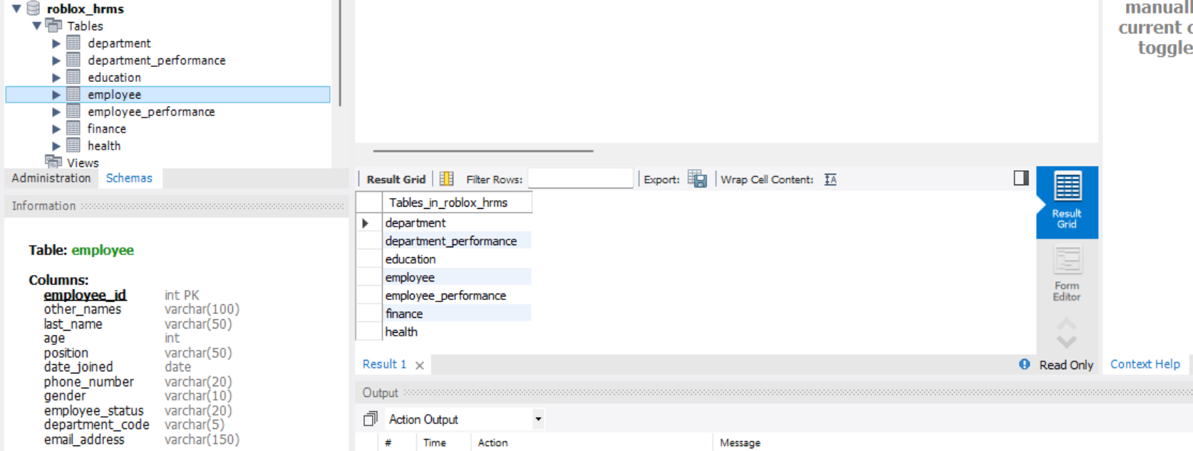
- employee_performance table and schema
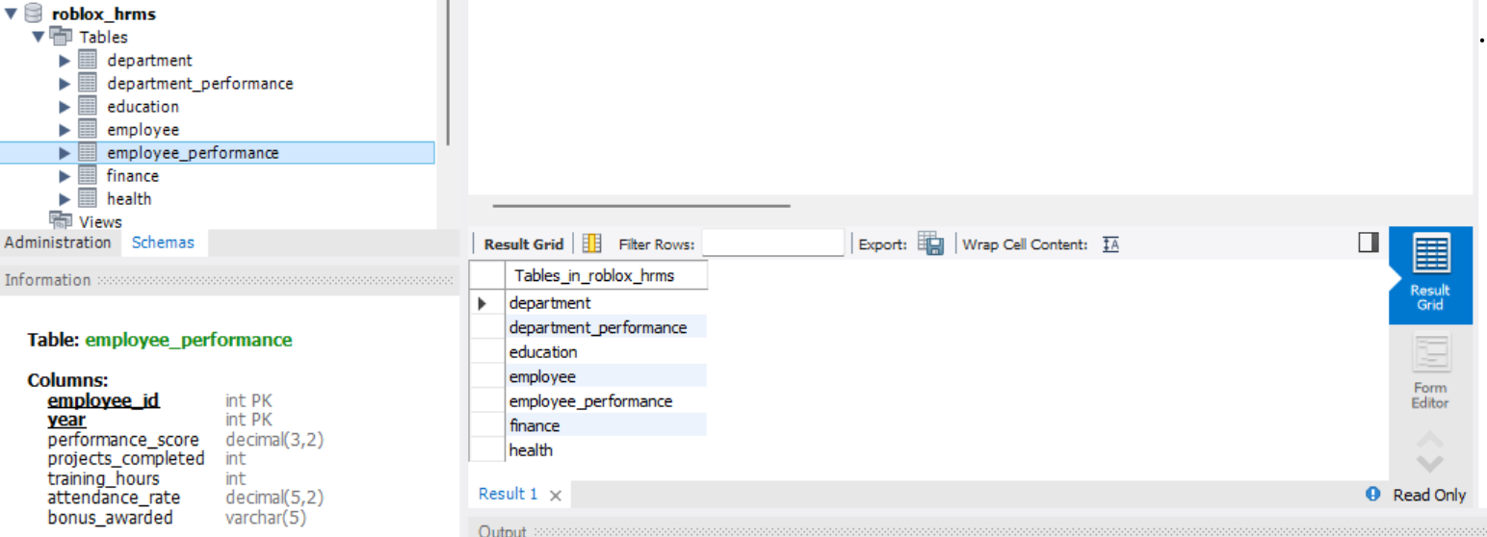

- finance table and schema
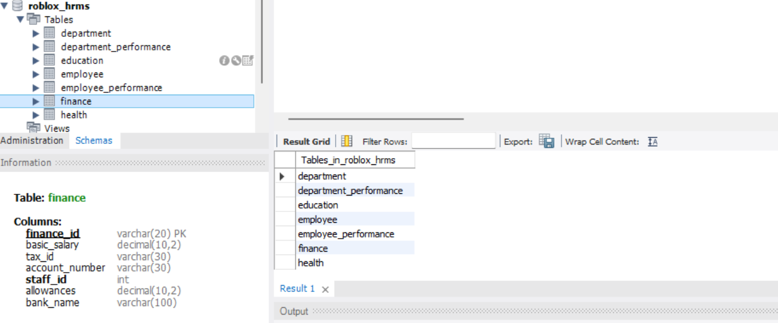

- The health table and schema
